


Christmas arrives with Izadittone

Villabuena de Álava, October 2024. The Izadittone of Bodegas Izadi is already one of the most awaited
Christmas sweets and is now available for Christmas food lovers to enjoy it. Its exquisite elaboration, based on pomace cream from the winery’s own grapes and Loison’s unique dough, make it unique and exclusive.
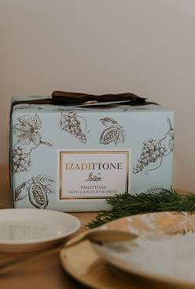
The first Izadittones arrived at Christmas in 2017 and their success was such that both the Italian brand Loison and Bodegas Izadi decided to continue their relationship to create this very special sweet every year.

The Italian bakery Loison, located in Vizenza (Italy), is one of the most prestigious in Italy, for the quality of its chocolates, its good work and its trajectory, and that is why Bodegas Izadi chose it to create this very different panettone. The elaboration of this sweet has become for Izadi in a Christmas tradition that can not be missed, and is a step forward it its commitment and union with gastronomy, which is where this winery from Alava was born by the Antón family.

Izadittone seduces every year for its taste, creaminess, authenticity, in both versions. A Classic Izadittone that, with aged pomace, is a tribute to the traditional Italian recipe to which raisins, orange and lemon are added, and the Izadittone with which this adventure began a few years ago and that has as protagonists the grape pomace of Bodegas Izadi and chocolate.

For Lalo Antón, CEO of the winery, “Izadittone makes us happy Christmas. It is a gastronomic jewel that is very difficult to produce without the secrets and the recipe book of Dario Loison. For us, this partnership with the Loison house is a commitment that will last for many years”.

Izadittone, unique panettone in Spain, is made with pomace cream obtained from the distillation of the grape skins of the winery's grapes and the secret recipe - more than 90 years old - of the sourdough of the Italian company Loison, considered the Ferrari of panettones thanks to its expertise since 1938.

Izadittone can now be purchased at www.artevinostore.es and gourmet stores.

PVP: 32,90

https://artevinostore.es/catalogo/regalos/izadittone-panettone-crema-orujo

Informative Notes: Bodegas Izadi was founded in 1987 by Gonzalo Antón, one of the most renowned winemakers. He created Izadi, which means nature in Basque, from the family vineyards of Rioja Alavesa and since then, his great work has been to take care of the old vineyards of this wine region to produce wines that show the four pillars that mark the philosophy of this brand: Respect, sensitivity, concern and hospitality. Currently, his son Lalo Antón runs this winery, parent company of Artevino Family Wineries (Finca Villacreces, Bodegas Vetus and Orben), which includes among its brands: Izadi, Izadi Larrosa, Izadi Selección and El Regalo. Since 2020 it holds the environmental seal “Wineries for climate protection”.
For more information:
Bodegas Izadi – Iván Pérez iperez@artevino.es – 616 51 05 86
Press – 10vcomunicacion – Victoria Díez victoria@10vcomunicacion.es – 629 682 802

